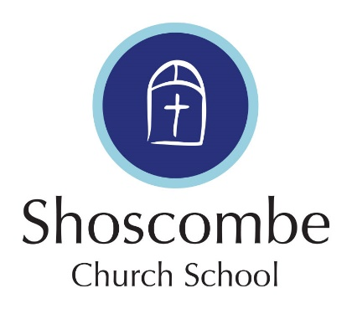
Breakfast Club Medical Form
All information contained on this form is held under the Data Protection Act 2018 and shall not be disclosed to any other party.
Pupil and contact details:
Pupils name:___________________________
Year group:____________________________ Class:______________________________
Please provide 2 contact details:
Name:________________________________ Contact number:________________________________
Name:________________________________ Contact number:________________________________
Medical information:
Does your son/daughter suffer with any medical conditions/allergies/disabilities/insect bites? Yes/No
Please give details

Does your child suffer from any conditions requiring medical treatment including medication? Yes/No
Please give details

Is your child taking any form of medication on a regular basis? Yes/No
Please give details including type of medication and dosage:

The school is aware of any of the above any medical conditions which my child has and the appropriate forms have been completed Yes/No
Dietary Requirements:
Please state below to indicate if your child has any specific dietary requirements or allergies:
Vegetarian Yes/No
Vegan Yes/No
Any other important dietary information/requests:

Parent/Guardian name: Signature:

