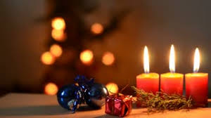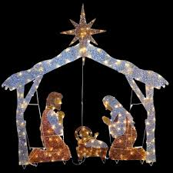 I

**Christian Value for the Term**

Respect

**What matters to children?**

Feeling happy, welcome and safe at school. Exploring, experimenting and learning together.

**Oak Class - Term 2 – Nov/ Dec 2018 – Celebrations**

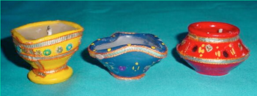

**Big words:**

Respect

Remembrance

Similar

Difference

Celebration Special

Erasmus

Festival

Nativity

Diwali

**English – Books, stories, drama, writing**

**Information books** about Diwali, Hannukah and Christmas

**Topic related stories and poems**

Firework Poems

Christmas Story

Nativity Play – Hey Ewe

Traditional tales from around the World

Harvey Slumfenburger’s Christmas Present

BBC Bite Size clips about

Diwali, Hannukah and Christmas

Writing letters to Father Christmas

Christmas recipes - Instructions

Christmas cards to our families and our Erasmus partners

Reading books /Guided reading

**Questions worth asking**

What is a celebration?

Why do people celebrate different things?

Where else in the World do people celebrate Christmas?

Why is light (candles, fireworks) an important part of many celebrations?

How are celebrations different?

How can we show Respect to others and to our environment?

**Visit**

Possible visit to Foxcote church

**Schemes of Work**

Awareness, Mystery and Value (RE) – Why are some stories special?

Real PE

PSHE (Jigsaw – Celebrating Difference)

**Children’s Questions**

See Learning Journals, displays and Our Class Big Book of Questions – What would we like to find out? Show & Tell and group/ class discussions

**Use**

Our wonderful outdoor area!

‘Mini-me’ models in Small World

Role Play / Small World

Blocks/construction

Natural objects

Variety of recycled objects and materials

Purple Mash Software

Bee Bots

Instruments to create celebration music and to accompany dances

**Investigate**

Phonics - Letters and Sounds Phase 2 – 5

**Year 1** - ‘real’ and ‘alien’ words

Numicon

Patterns for handwriting

Different ways of moving

Cooking – changing states

**Make**

Firework pictures

Remembrance poppies

Diva Lamps

Representations / pictures of Celebrations using a variety of materials and processes (ie paint, pastel, 2D collage, 3D construction and modelling materials, ICT)

Christmas Art

Art using recycled materials

Food for different Celebrations

For Next Time…

**Mathematics Year 1**

White Rose Maths – Whole Part Models, Addition, Subtraction Number Bonds, Number lines

Problem Solving, Using Number lines

Using mathematical language

**Reception**

Counting objects accurately

One more / one less than a number 1-5 – counting on and back

Language of addition and subtraction

Everyday language related to Money

Measuring Weight and Capacity - Cookery

**Collect** Topic related pictures and objects to bring in from home to share with the class